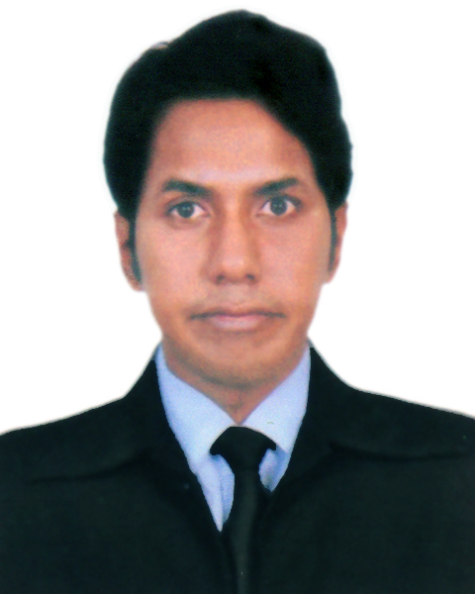
Naimul Bari
House No – 32/C/1. East Nayatola.
Ramna. Dhaka – 1217.
Cell No: +8801816501074.
E-mail: naimulpavel@gmail.com

Career Objective
I have a dynamic and challenging attitude towards my assigned responsibility. I am confident about my ability, responsibility, labor and skills; I want to build my career within Management based organization.

Work Experience

Internship Experience:
I completed my internship from National Bank Ltd. During my internship I worked in Overall Banking Department and prepared an internship report on “Foreign Exchange Operation of National Bank Limited”.

Organization : Tamijuddin Textile Mills Limited
Organization Category : Textile Mill
Degination : Executive Admin – Admin Dept.
Key Responsibility : Dealing with managing office stock, preparing
regular reports (e.g. expenses and office budgets)
and organizing company records
Duration : 01.01.2016 to 31.07.2020.
Organization Fair Builders Ltd.
Organization Category : Real Estate
Degination : Executive Officer – Admin Dept.
Key Responsibility : Dealings with administrative issue and solving
staff complaints as priority basis.
Duration : 01.01.2015 to 31.12.2015

Training Summary:

Training Title : Orientation Training Program
Organization : National Training Institute
Topic : Concept on overall General and Retail banking area.
Duration : 5 days.
Training Title : Digital Marketing Training
Organization : BITM
Topic : Strategies Focused on Increasing the Reach &
Visibility.
Duration : 30 day.

Academic Qualifications

Course  Title | Year of passing | Institution |  | Result | Major/  Group
MBA | 2014 | Stamford University Bangladesh |  | 3.50 | Finance
BBA | 2011 | Stamford University Bangladesh |  | 3.00 | Finance
HSC | 2004 | B.A.F.Shaheen College. Dhaka |  | 3.80 | Business Studies
SSC | 2002 |  | Tejgaon Govt. High School. Dhaka | 3.00 | Science

Computer Skills
- Ms–Dos, Ms–Word, Ms–Excel, Ms–Power Point, Hardware, Software and Fax.
- Good typing skill both in English & Bengali.

Language Proficiency
Excellent verbal written and interpersonal communication skills with strong command over both Bengali and English language.

Duties & Responsibility
Potential project sites to conduct initial feasibility of the proposed project;
Project appraisal including development of financial model for investment proposal;
Assist potential sponsors in developing project;
Generate periodic and other reports required by govt. agencies from time to time;

Strength
Strong organizational & planning skills;
Excellent customer focus and target oriented selling exists;
Advanced analytical skills to a wide range of problems;
Excellent interpersonal and communication skills to establish good rapport with customer;
Self-motivated, enthusiastic individuals with strong drive to achieve target within deadlines;
Ability to handle customer issue and maintain robust client relationship;
Excellent management and stress management attributes;
Geographic mobility and flexibility;

Interest & Hobbies
Reading (Newspaper, Novels, &Magazines) Traveling, Internet Browsing, Watching English Action Movie, Playing Foot Ball & Cricket.

Personal Information

Full Name : Naimul Bari
Father’s Name : Khondaker Mohammad Jahangir
Senior Officer (Rtd.), Janata Bank.
Mother’s Name : Fatema Jahan
Permanent Address : Village-Birahimpur, Post Office- Basantapur,
Thana- Shenbag, District- Noakhali.
Present Address : 32/C/1 East Nayatola.Mogbazar. Dhaka-1217.
Contact no. : Mob: 01816501074, 01670819203.
Nationality : Bangladeshi.
Religion : Islam.
Date of Birth : 8th May, 1988.
National ID card No : 2696654358064
Marital Status : Single

References

1. Humayun Kabir  Senior Assistant Vice President & Audit  Shahjalal Islami Bank Ltd.  Gulshan - 2. Dhaka.  Mob: 01755-556322 | 2. Khondaker Nurun Nabi  SEVP(Rtd.)  National Bank Ltd.  Motijheel C/A. Dhaka.  Mob: 01713-388898
3. Hamidul Haque Khan
National Project Manager
United Nations Development Programme
Kakrail. Dhaka.
Mob: 01713-014027

DECLARATION

I solemnly affirm that the above information is true to the best of my knowledge and belief.

